CMPEN 472, Homework 11, CodeWarrior Full Chip Simulator (Debugger) Guide

This is an additional Guide over the CMPEN 472 CodeWarrior Full Chip Simulator Guide for the Homework 11.

In order to simulate Analog-to-Digital Converter (ADC) with CodeWarrior, a few additional steps are necessary to generate an analog signal. Mainly one will need to issue a CodeWarrior command to connect the ADC input pin to a signal generator, and provide a signal wave file. As an example, the Homework 11 sample program project is created following the CMPEN 472 CodeWarrior Full Chip Simulator Guide. Copy the Homework 11 sample program source, click ‘Make’ and then ‘Debug’. Add and setup the Terminal component in the simulator. You may remove the Data window and Procedure window, but you need to keep the Command window in the simulator. Be sure to SAVE the Debug/Simulator Configuration, then quit the Debug/Simulator, and restart it - for your simulator setup to take effect. Before you start the simulation to run your program, take the following additional steps:

Copy the two files ‘ADCcon7.cmd’ and ‘WAVEsn10.cmw’ files to your project folder.

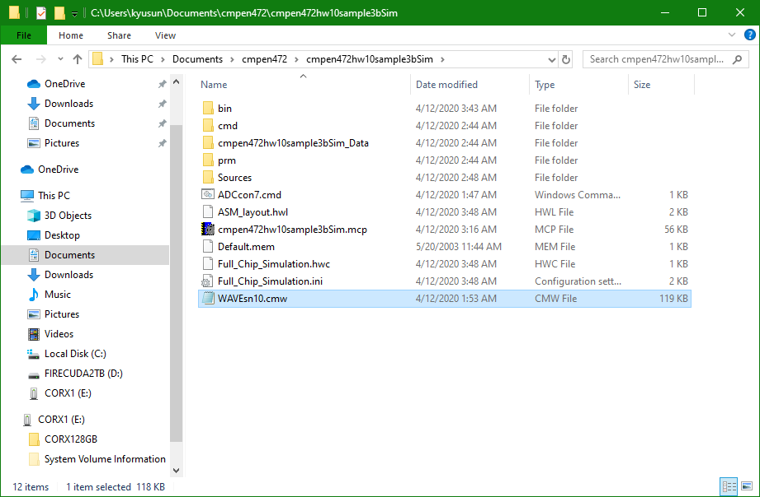

Right click on the ‘Command’ window. Select Execute File option.

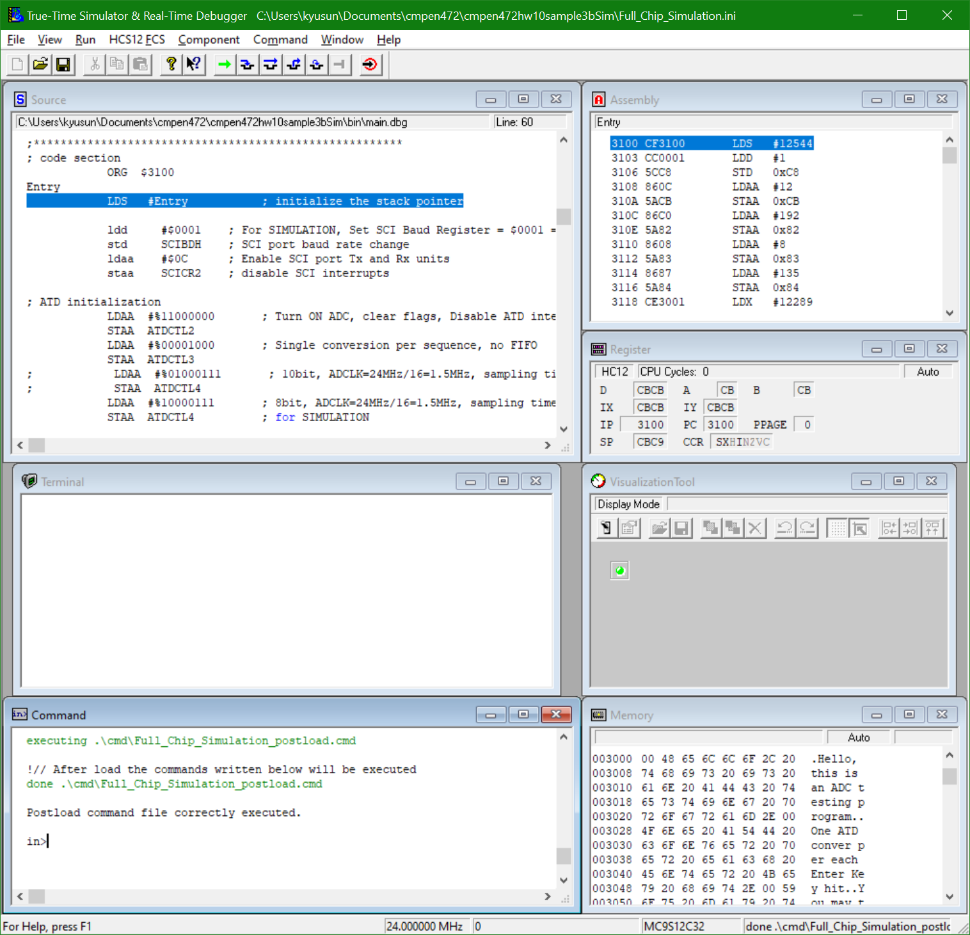

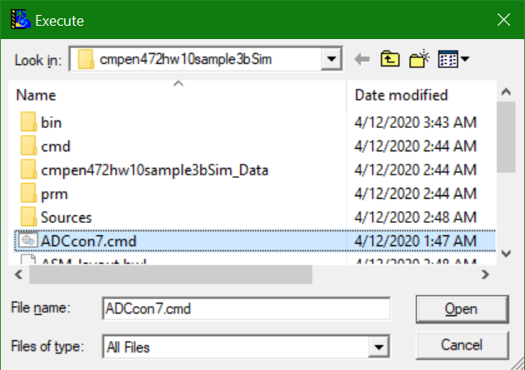

Click on Terminal window. And run program.

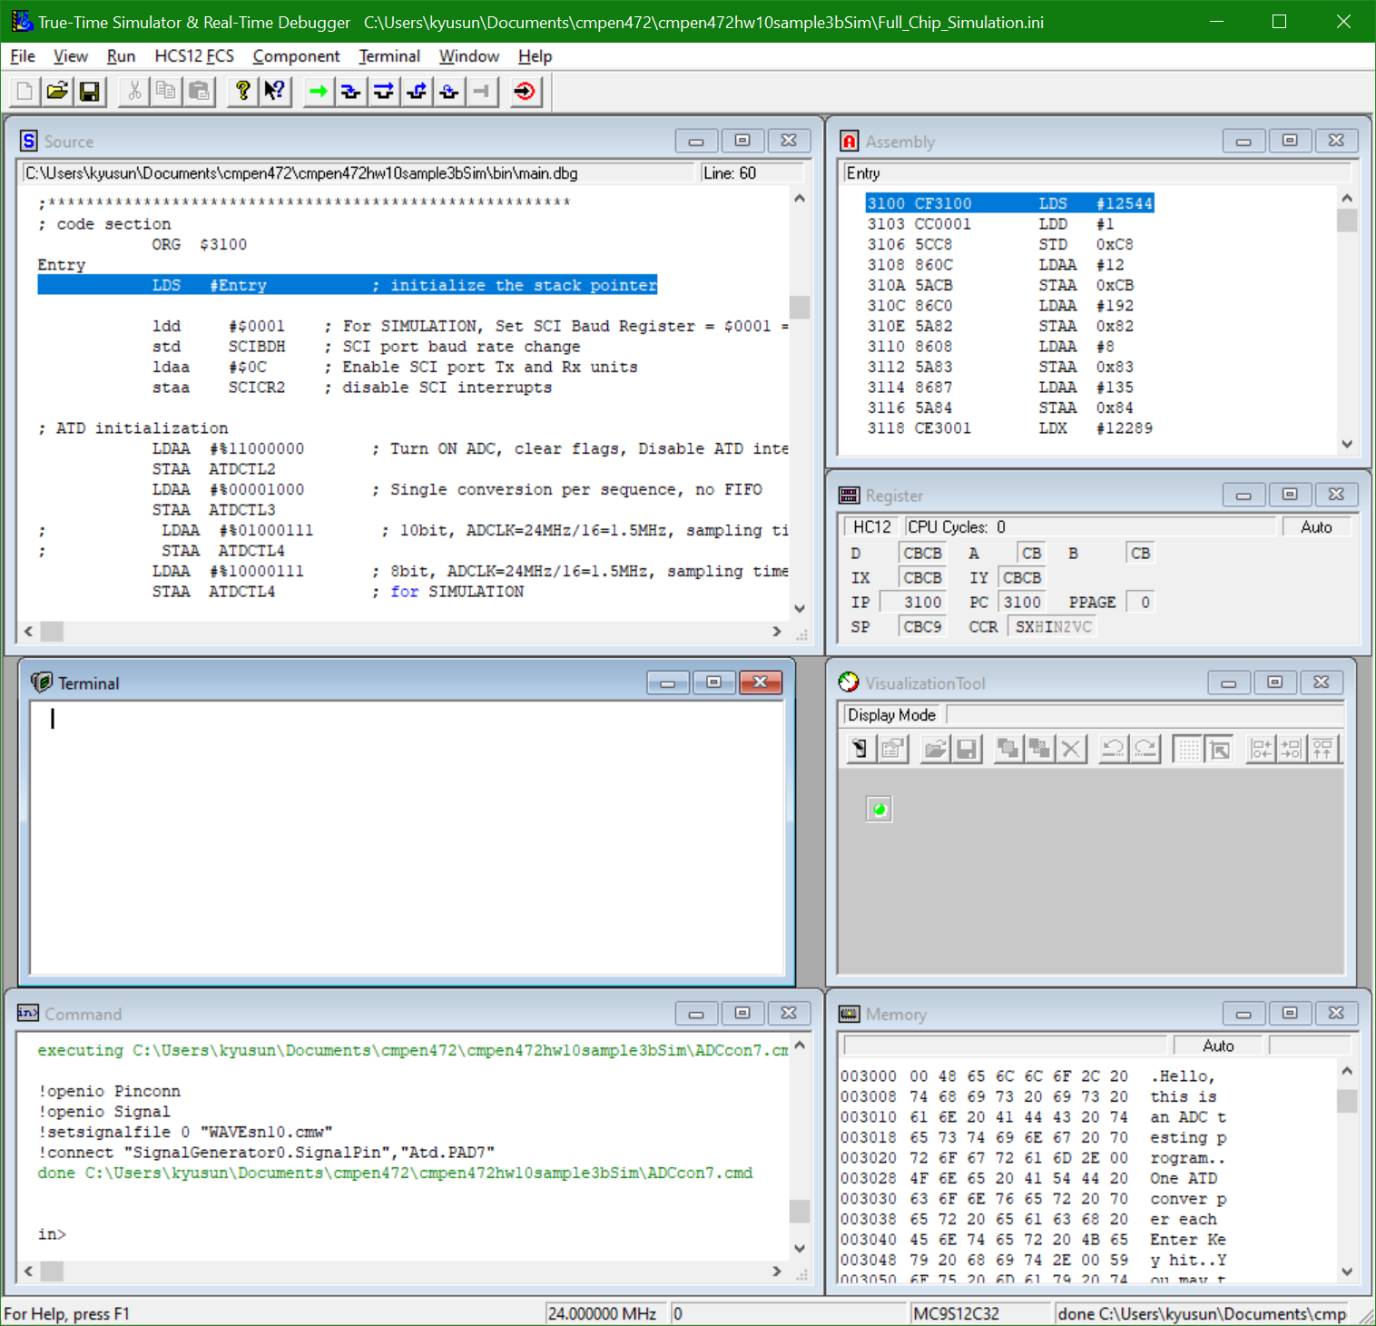

As your program is running, hit enter key. You may keep hitting enter keys, to get the analog signal value.

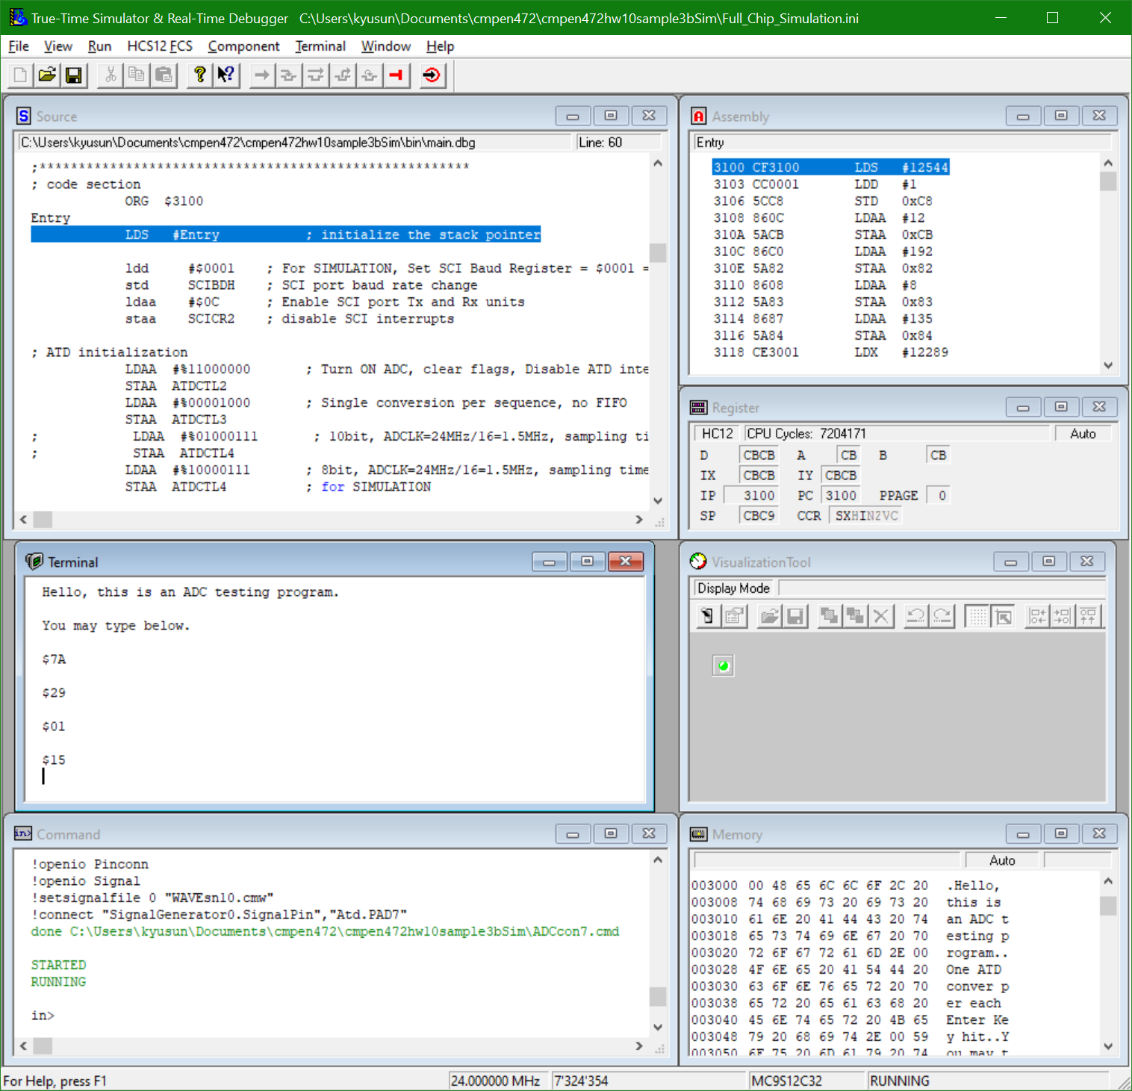

If you see the numbers printed on the Terminal is changing, your sample program is working! And if you look at the numbers carefully, you will notice it is sine wave anywhere from 10Hz to 100Hz range.

